**TEAM MEMBERS DETAILS**

GROUP NAME: PACHACUTEAM

SPECIALIZATION: Data Science

|  |  |  |  |
| --- | --- | --- | --- |
| Name | Email | Country | College/Company |
| Andersson Romero | [andromdez@gmail.com](mailto:andromdez@gmail.com) | Perú | Freelancer |

**Categorical Data Analysis**

* Feature Relevance

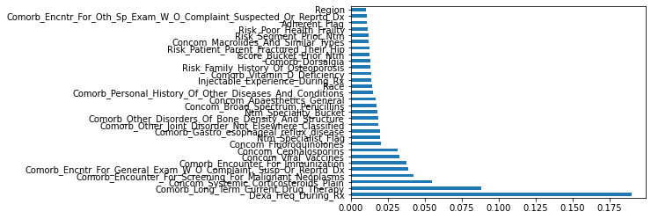

* Pariplot

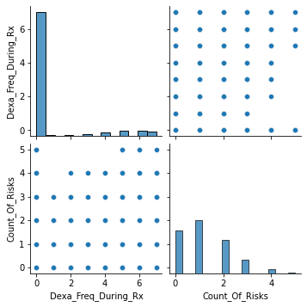

* Chi Square

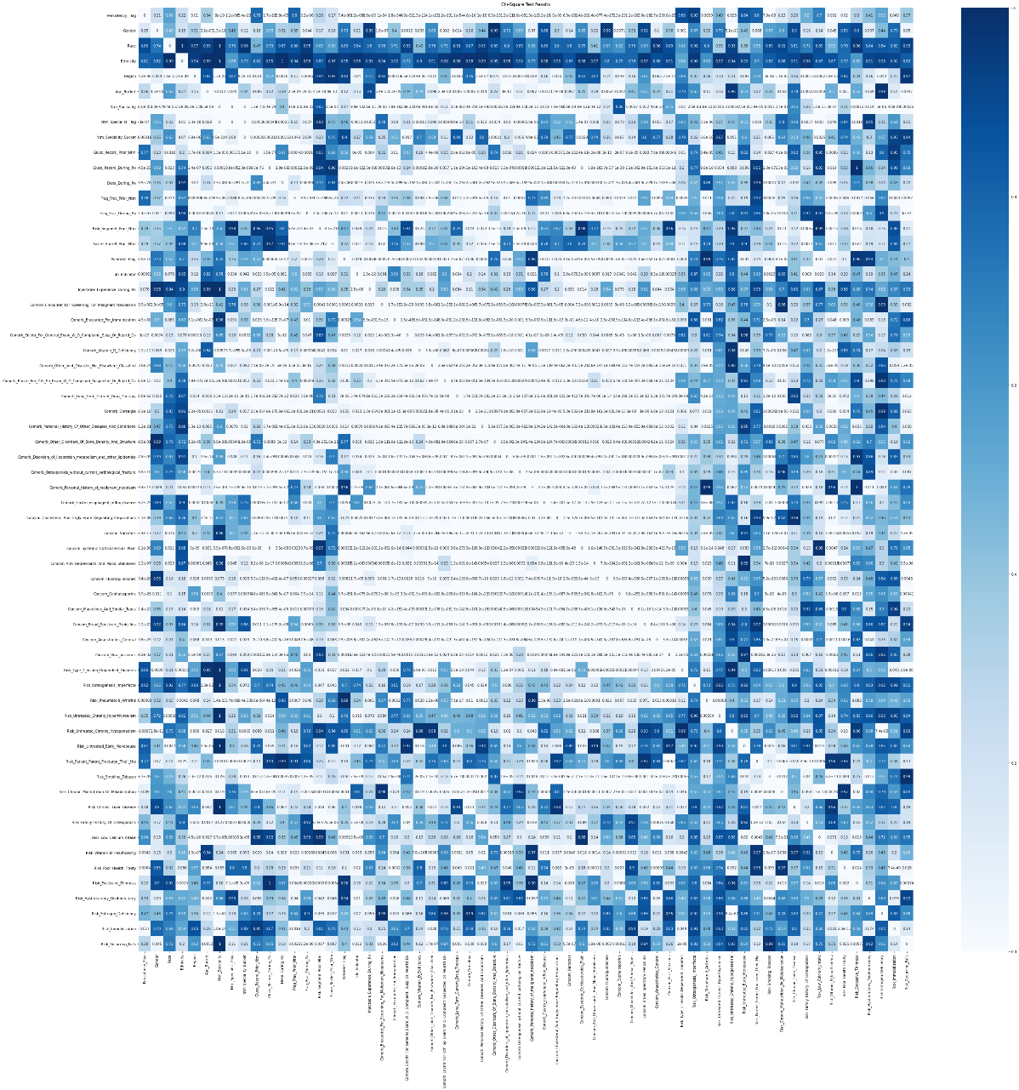

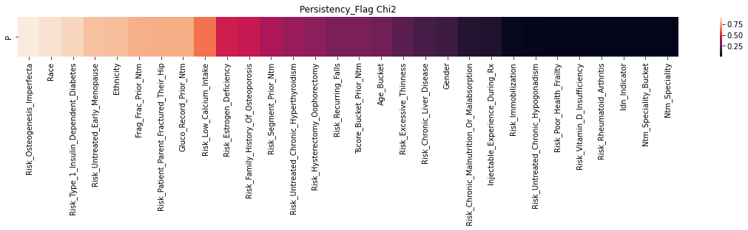

* Correspondence Analysis

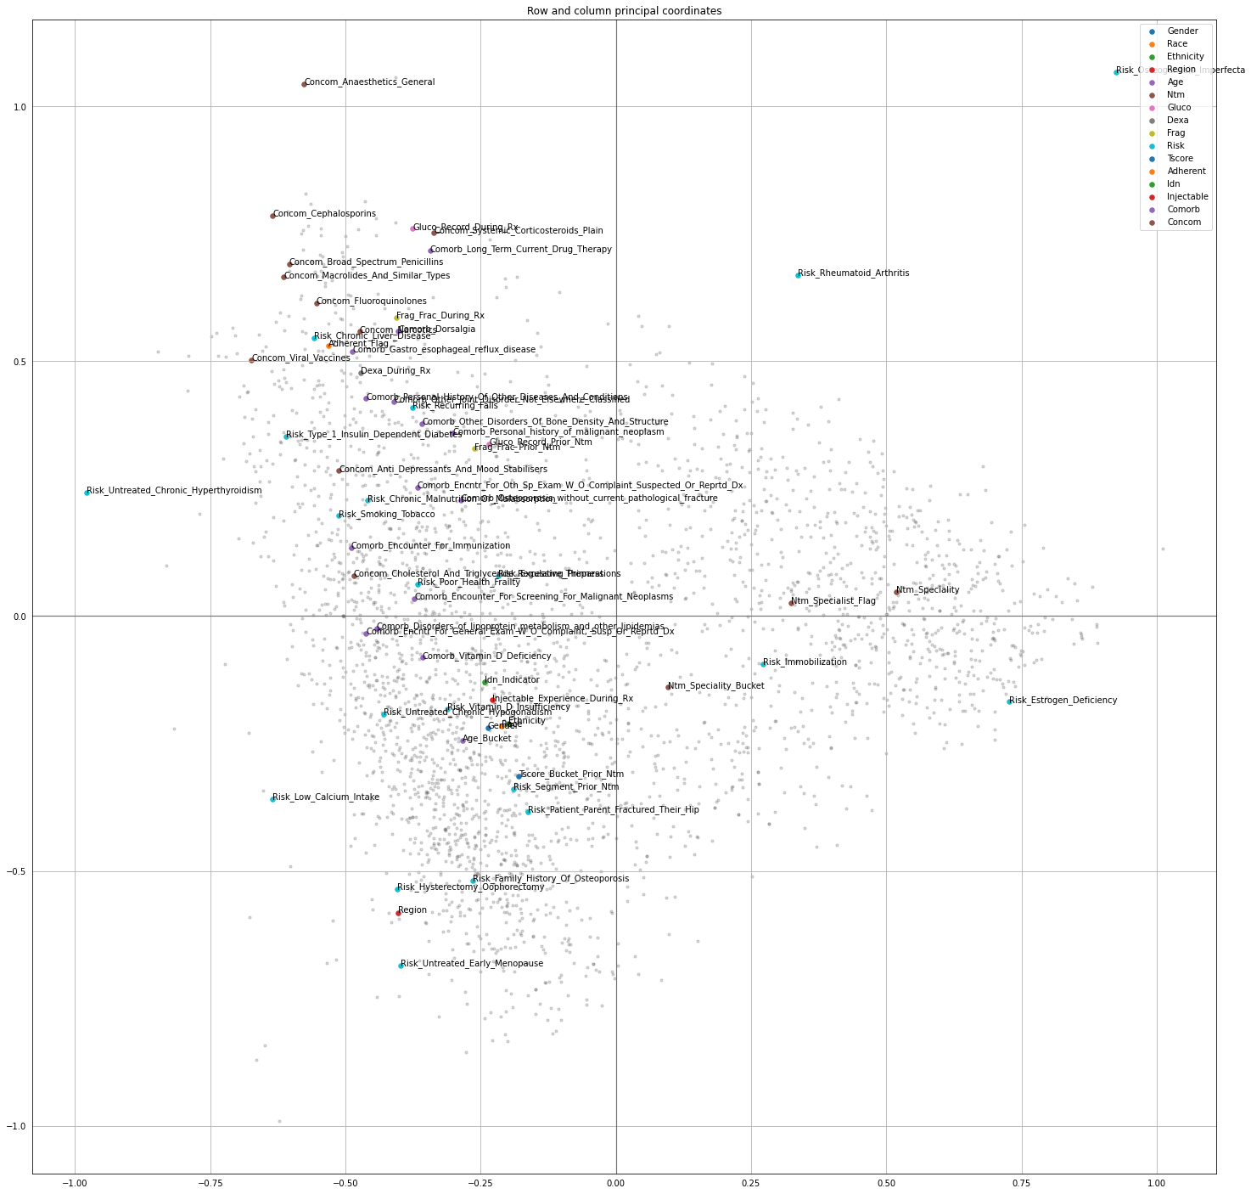

* Tornado chart

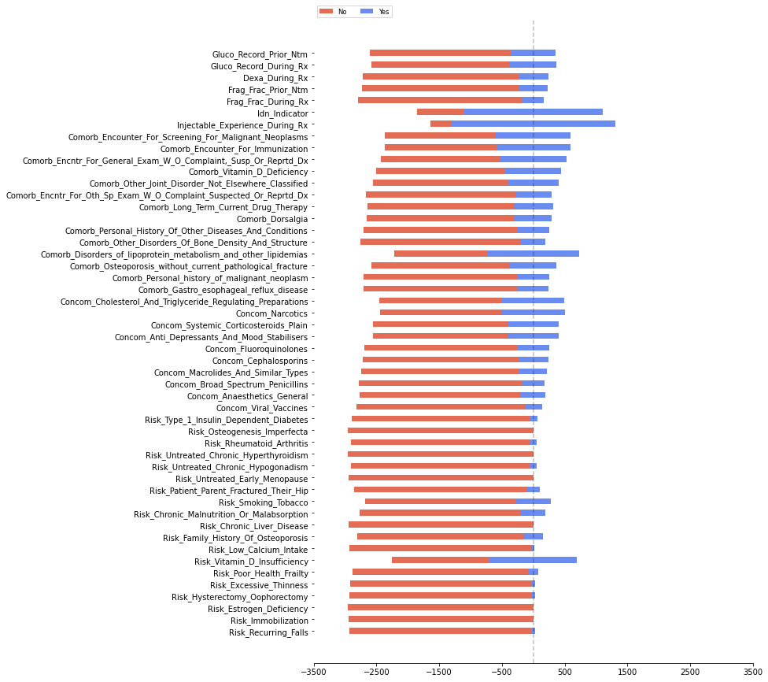

* Cross tab

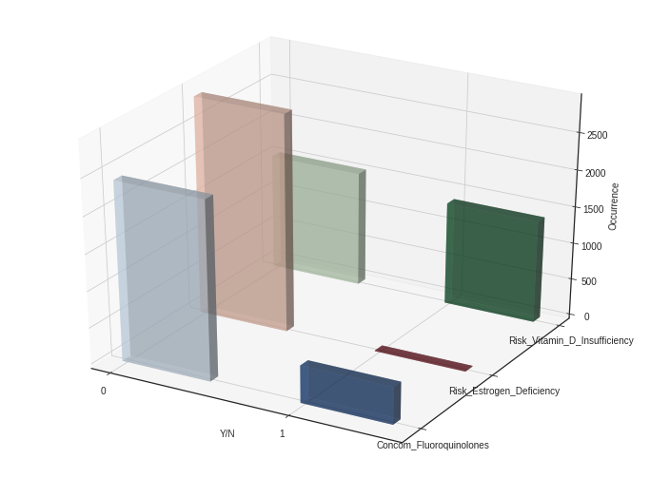

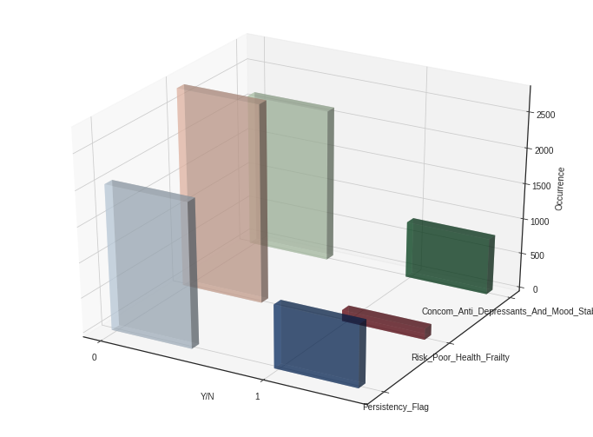

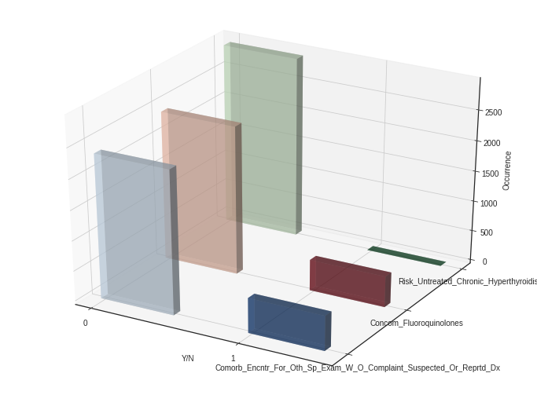

**DATA INTAKE REPORT**

Name: Healthcare project

Report date: 17/04/2022

Internship Batch: [LISUM07](https://canvas.instructure.com/courses/3110044)

Version: 1.0

Data intake by: PACHACUTEAM

Data intake reviewer:<intern who reviewed the report>

Data storage location: GitHub

**Tabular data details:**

|  |  |
| --- | --- |
| **Total number of observations** | 3424 |
| **Total number of files** | 1 |
| **Total number of features** | 69 |
| **Base format of the file** | .xlsx |
| **Size of the data** | 899 KB |

**GITHUB LINK:** https://github.com/And2300/Healthcare_PersistencyDrug